

|  |  |  |  |  |
| --- | --- | --- | --- | --- |
| **Student Name:** | | Avagimyants Timur Olegovich | | |
| **Student ID:** | | B2100093 | | |
| **Course:** | | BS (Hon) in Computer Information Systems for Business | | |
| **Module Code and Title:** | | ICE1411 – Web Technologies | | |
| **Module Leader:** | | Mr. Jackson Lau Chong Tek | | |
| **Module Tutor:** | | Engr. Eugene Q. Castro | | |
| **Assessment:** | | Assignment 1 | | |
| **Due Date:** | 2 May 2023 | | **Date Submitted:** | 2 May 2023 |
| **Weighting within Module:** | | **50%** | | |
| **ALL MARKS ARE PROVISIONAL AND ARE SUBJECT TO CHANGE UNTIL CONFIRMED BY THE EXTERNAL EXAM BOARD** | | | | |
| **Comments from Internal Examiner (Name):** | | | | |
| **Strengths:** | | | | |
| **Weaknesses:** | | | | |
| **Areas of Improvement:** | | | | |
| **Provisional Mark out of 100:** | | |  | |

Table of Contents

Task 1 - Structure and Content of Webpage i

Site Map i

Online Hosting ii

Search-Engine Optimization (SEO) ii

Responsive Web Design (RWD) v

Internal and External links to and from every page on your site v

Task 2 - Style your Webpage vi

External Style Sheet vi

Pseudo-Classes used in Website viii

Web Font used in Website viii

View of website in different device ix

Desktop ix

Task 3 - Building an 3x3 image gallery from a JSON object x

image Gallery x

I x

JSON File xi

JavaScript Code xii

Task 4 - Create an interactive image carousel from a JSON object xiv

Framework Used for Carousel xiv

HTML, CSS and JS Code xv

Task 1 - Structure and Content of Webpage

Site Map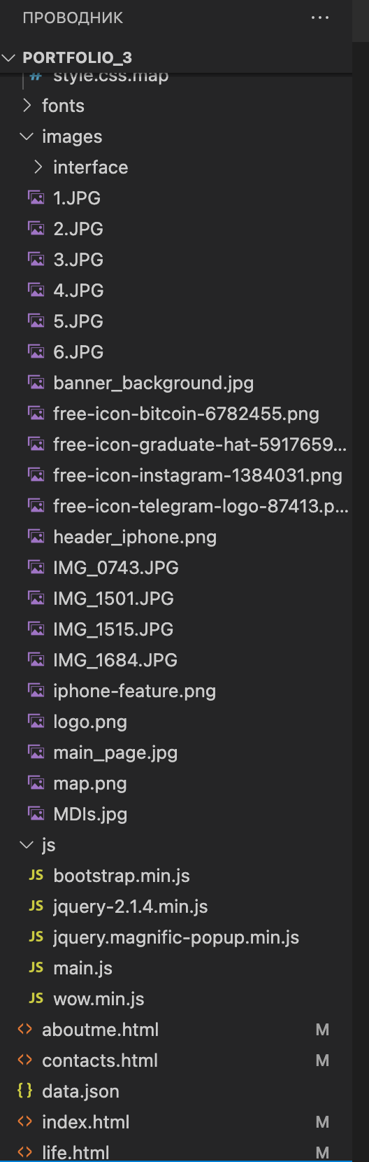

There are types of files such as css file includes of style of site, image file where all images store , js file is JavaScript file where all about behavior of website.

Pages about.html    - home page

Contacts.html – contact page

life.html – gallery page

index.html – portfolio page

Online Hosting

This assignment hosted on git hub

Here is the link, to my git hub account

https://github.com/x-code-x-sudo/portfolio

Search-Engine Optimization (SEO)

<!DOCTYPE html>

<html lang="en">

<head>

<meta charset="utf-8">

<meta http-equiv="X-UA-Compatible" content="IE=edge">

<meta name="viewport" content="width=device-width, initial-scale=1">

<!-- The above 3 meta tags *must* come first in the head; any other head content must come *after* these tags -->

<title>New Providence</title>

<link href='https://fonts.googleapis.com/css?family=Roboto:400,300,700,500' rel='stylesheet' type='text/css'>

<link rel="stylesheet" href="fonts/font-awesome/css/font-awesome.min.css"> <!-- Font Awesome -->

<link rel="stylesheet" href="css/normalize.css"> <!-- CSS reset -->

<link rel="stylesheet" href="css/bootstrap.min.css"> <!-- Bootstrap Grid -->

<link rel="stylesheet" href="https://cdn.linearicons.com/free/1.0.0/icon-font.min.css">

<link rel="stylesheet" href="css/animate.min.css"><!-- Animate -->

<link rel="stylesheet" href="css/style.css"> <!-- Resource style -->

<link rel="stylesheet" href="css/magnific-popup.css"> <!-- Resource style -->

</head>

body>

<header id="main-nav">

<div class="container">

<div class="row">

<div class="col-md-4">

<ul class="left">

<li><a href="/life.html">Life</a></li>

<li><a href="/aboutme.html">About me</a></li>

<li><a href="/contacts.html">Contacts</a></li>

</ul>

</div>

<div class="col-md-4 text-center">

</div>

<div class="col-md-4">

<ul class="right">

<li><a href="https://t.me/TimAv3110" class="help">Help</a></li>

<li><a href="https://t.me/topchik_teens">Channel</a></li>

</ul>

</div>

</div>

</div>

</header><!-- //Main Nav -->

<section id="header">

<div class="container">

<div class="row">

<div class="col-md-8 col-md-offset-2 text-center">

<h1 class="wow fadeInUp">Timur Avagimyants Olegovich</h1>

<h3 class="wow fadeInUp" data-wow-delay=".2s">Second year student at Computer information Systems for Business faculty at MDIST</h3>

</div>

</div>

</div>

</section><!-- //Header -->

<section id="iphone-feature">

<div class="container">

<div class="row">

<div class="col-md-5 col-md-offset-7">

<h2>

Crypto experience

</h2>

<p>

As in contemporary world crypto is spreading more and more this industry also didn't come across

me.

<br><br>

Due to my strong interests and open source internet platforms i was able to achieve some goals

in this sphere. Learn such things like arbitrage, investing for long and short time.

</p>

<div class="btns-container">

<a href="https://accounts.binance.com/en/login" class="btn btn-blue">Binance<i

class="fa fa-arrow-right"></i></a>

<a href="https://coinmarketcap.com/" class="btn">Learn More</a>

</div>

</div>

<div class="iphone-showcase wow fadeInLeft">

<div class="device">

<img src="images/iphone-feature.png" alt="">

</div>

</div><!-- //iPhone Showcase -->

</div>

</div>

</section><!-- //iPhone Feature -->

<footer id="footer">

<div class="container footer-container">

<div class="row">

<div class="col-md-3">

<p>Short guideline of how you can reach me and ask any questions related to my skills</p>

<ul class="socials">

<li><a href="https://t.me/TimAv3110"><img style="width: 20px; height: 20px;"

src="images/free-icon-telegram-logo-87413.png" alt=""></a></li>

<li><a href="https://instagram.com/tim.av?igshid=YmMyMTA2M2Y="><img style="width: 20px; height: 20px;"

src="images/free-icon-instagram-1384031.png" alt=""></a></li>

</ul>

</div>

<div class="col-md-2 col-md-offset-3 col-sm-4 col-xs-6 footer-links">

<ul>

<li>

<p class="title">Guide among website</p>

</li>

<li><a href="/index.html#header">Personal Info</a></li>

<li><a href="/life.html#iphone-feature">Crypto Experience</a></li>

<li><a href="/index.html#features">Current activities</a></li>

<li><a href="/index.html#iphone-screens">Plans</a></li>

</ul>

</div>

<div class="col-md-2 col-sm-4 col-xs-6 footer-links">

<ul>

<li>

<p class="title">Skills</p>

</li>

<li><a href="/aboutme.html#map-feature">Activity</a></li>

<li><a href="/aboutme.html#customers">Close people</a></li>

</ul>

</div>

<div class="col-md-2 col-sm-4 col-xs-6 footer-links">

<ul>

<li>

<p class="title">Contact</p>

</li>

<li><a href="/contacts.html#ready-to-buy">e-mail</a></li>

<li><a href="/contacts.html#subscribe">Subscribe</a></li>

</ul>

</div>

</div>

</div>

<div class="container copyright-container">

<div class="row">

<div class="col-md-6 text-left">

<div class="more-info">

For more freebies visit: <a href="https://t.me/TimAv3110">Timur's Telegram</a>

</div>

</div>

<div class="col-md-6 text-right">

<div class="made-by">Made with Love by <a href="#" target="_blank"><img style="width: 20px; height: 20px;"

src="images/main_page.jpg" </div>

</div>

</div>

</footer>

<script src="js/jquery-2.1.4.min.js"></script> <!-- jQuery -->

<script src="js/bootstrap.min.js"></script> <!-- Bootstrap -->

<script src="js/wow.min.js"></script> <!-- wow -->

<script src="js/jquery.magnific-popup.min.js"></script> <!-- wow -->

<script src="js/main.js"></script> <!-- Main Script -->

</body>

</html>

In this example, we've included the following SEO elements:

<title> tag: This is the title of the page, which should be descriptive and include relevant keywords.

<meta name="description"> tag: This provides a brief summary of the content of the page, and should also include relevant keywords.

<meta name="keywords"> tag: This provides a list of keywords that are relevant to the content of the page.

<meta name="author"> tag: This indicates the author of the page.

<meta name="viewport"> tag: This sets the viewport size of the page, which is important for mobile optimization.

By including these elements, we're providing search engines with more information about the content of the page, which can help improve its visibility and ranking in search results.

Responsive Web Design (RWD)

Responsive design is the approach of creating a website that can adjust its layout and content to adapt to different screen sizes, such as desktops, tablets, and mobile devices. Here are the steps to implement responsive design on HTML:

**Use CSS media queries**: CSS media queries allow you to apply different styles to a page based on the size of the screen. For example, you can set the width of the content to be 100% on smaller screens, and adjust the font size and spacing accordingly. Here is an example of how to use media queries:

**Use flexible typography**:

**Use of bootstrap**. Bootstrap is a framework with responsive CSS adjusts to phones, tablets, and desktops.

<link href="https://cdn.jsdelivr.net/npm/bootstrap@5.1.3/dist/css/bootstrap.min.css" rel="stylesheet">

<script src="https://cdn.jsdelivr.net/npm/bootstrap@5.1.3/dist/js/bootstrap.bundle.min.js"></script>

Internal and External links to and from every page on your site

<https://t.me/TimAv3110>

<https://t.me/topchik_teens>

<https://www.instagram.com/tim.av/?igshid=YmMyMTA2M2Y=>

<https://accounts.binance.com/en/login>

<https://coinmarketcap.com/>

Task 2 - Style your Webpage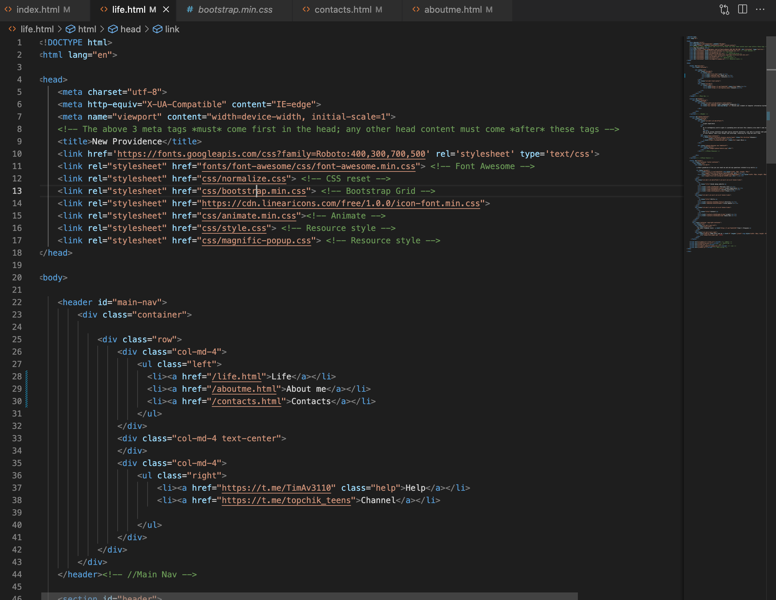

External Style Sheet

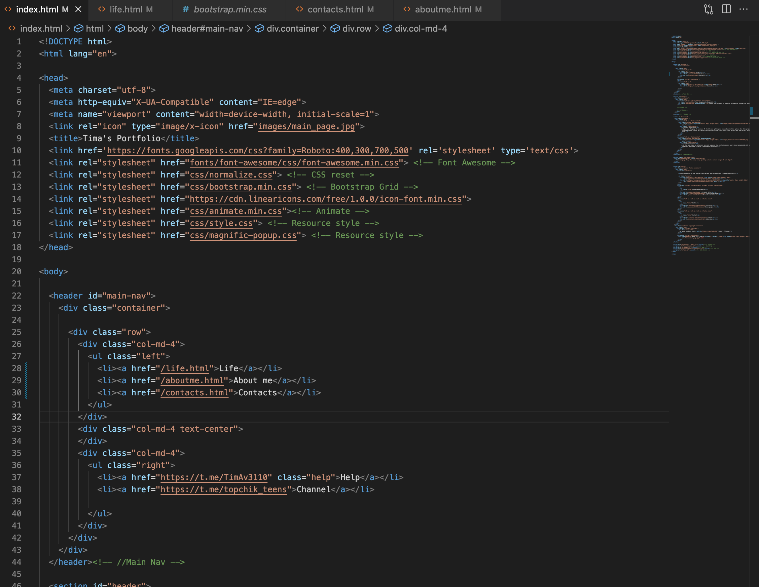

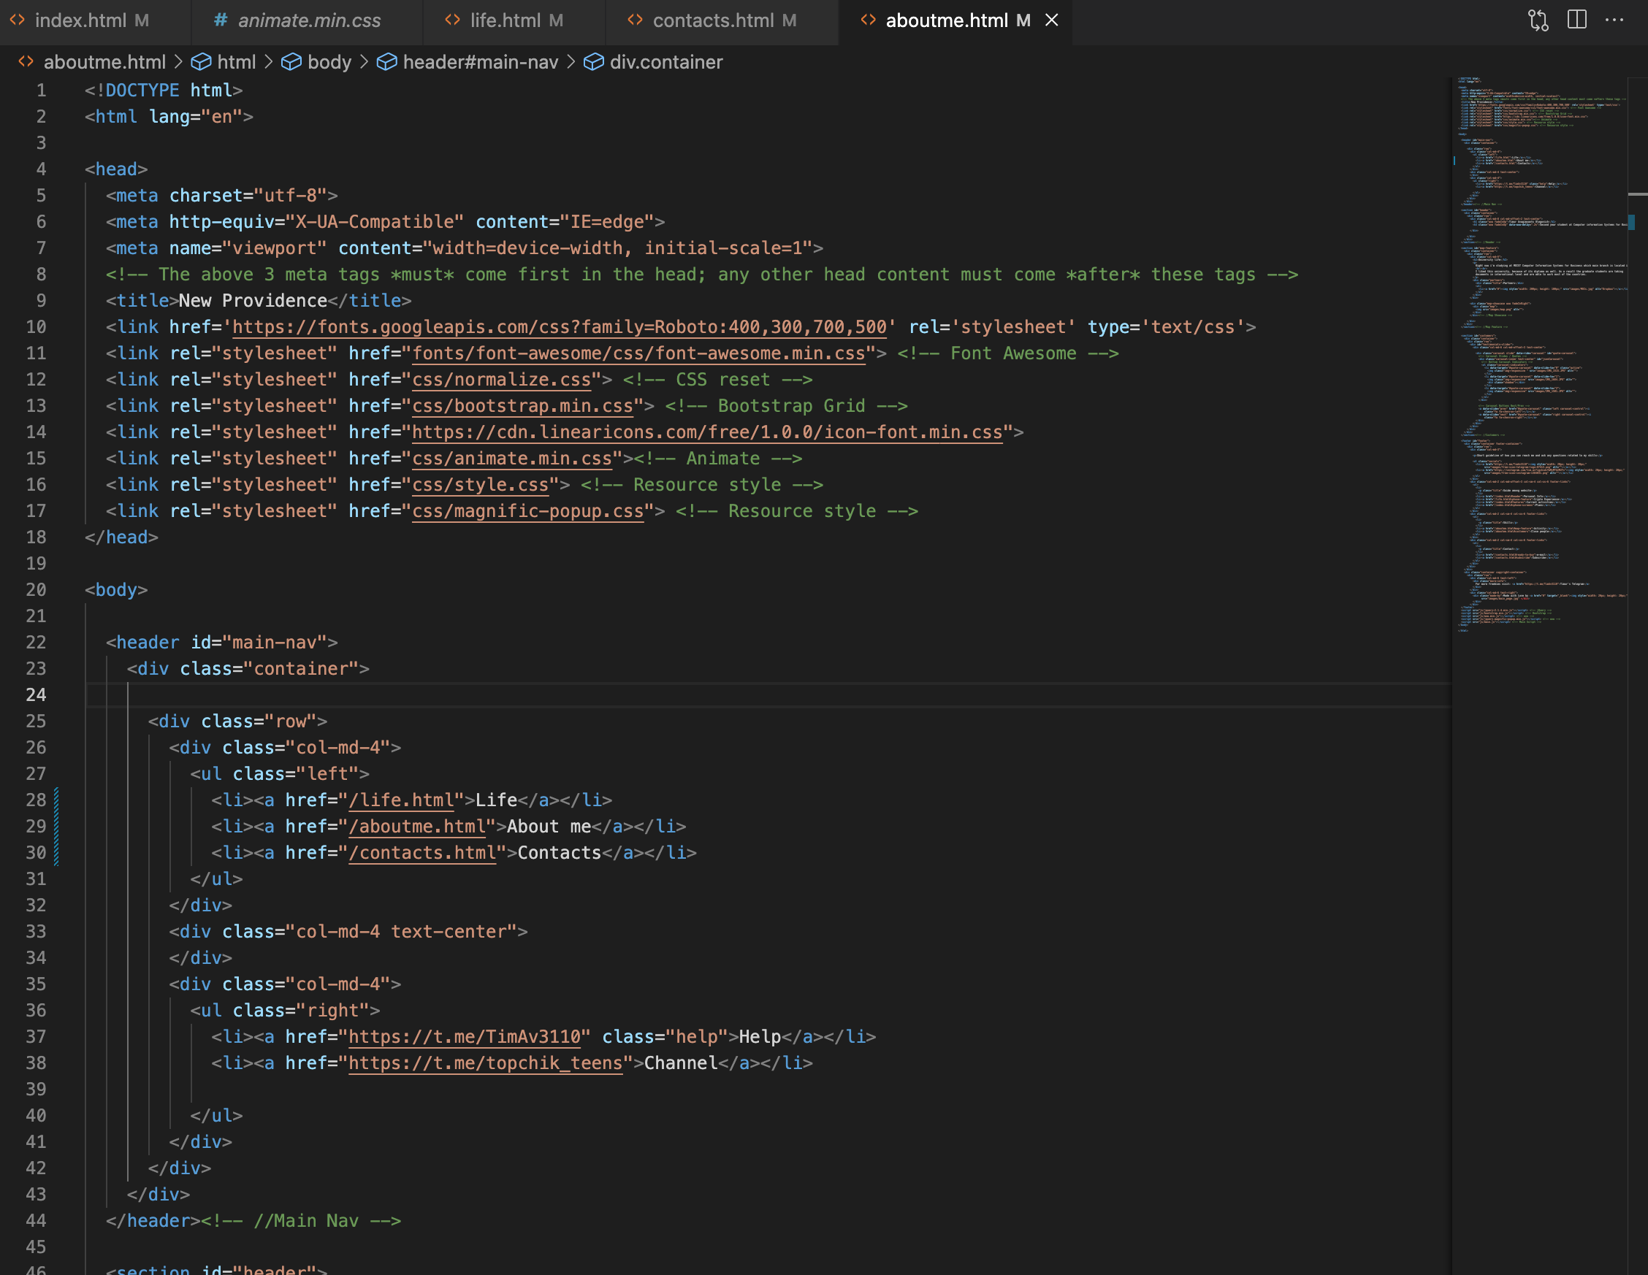

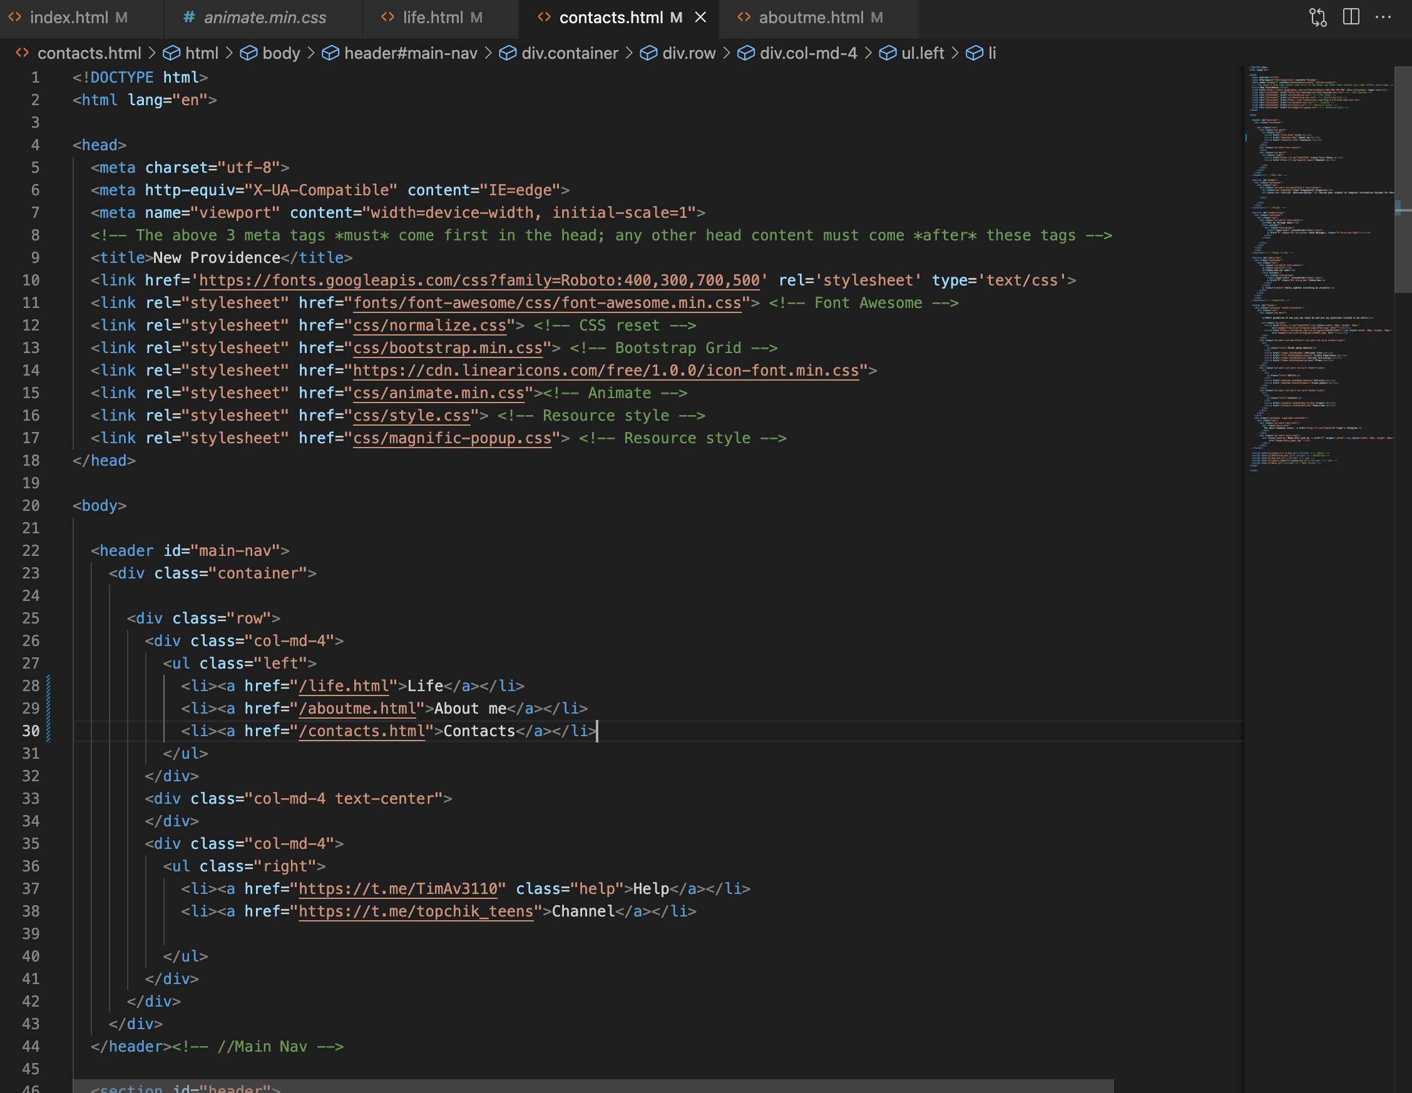

Pseudo-Classes used in Website

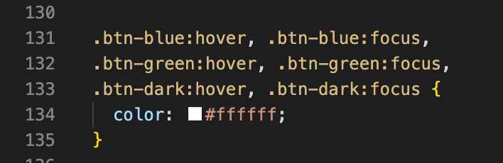

Web Font used in Website

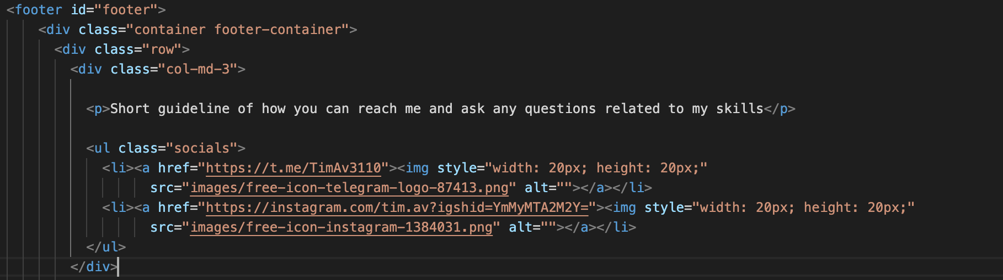

View of website in different device

Desktop



Task 3 - Building an 3x3 image gallery from a JSON object

image Gallery

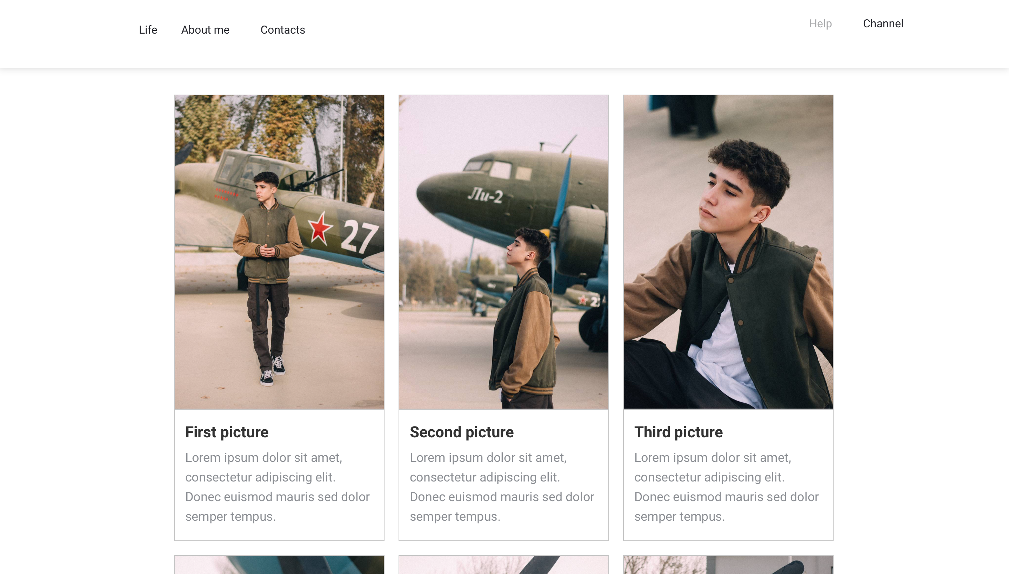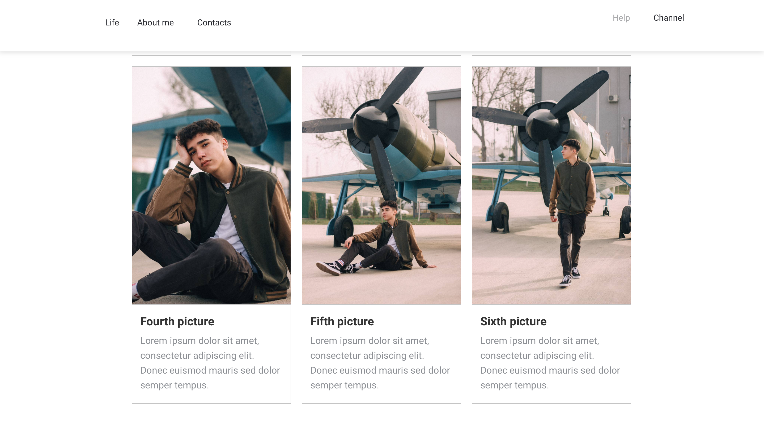

I

JSON File

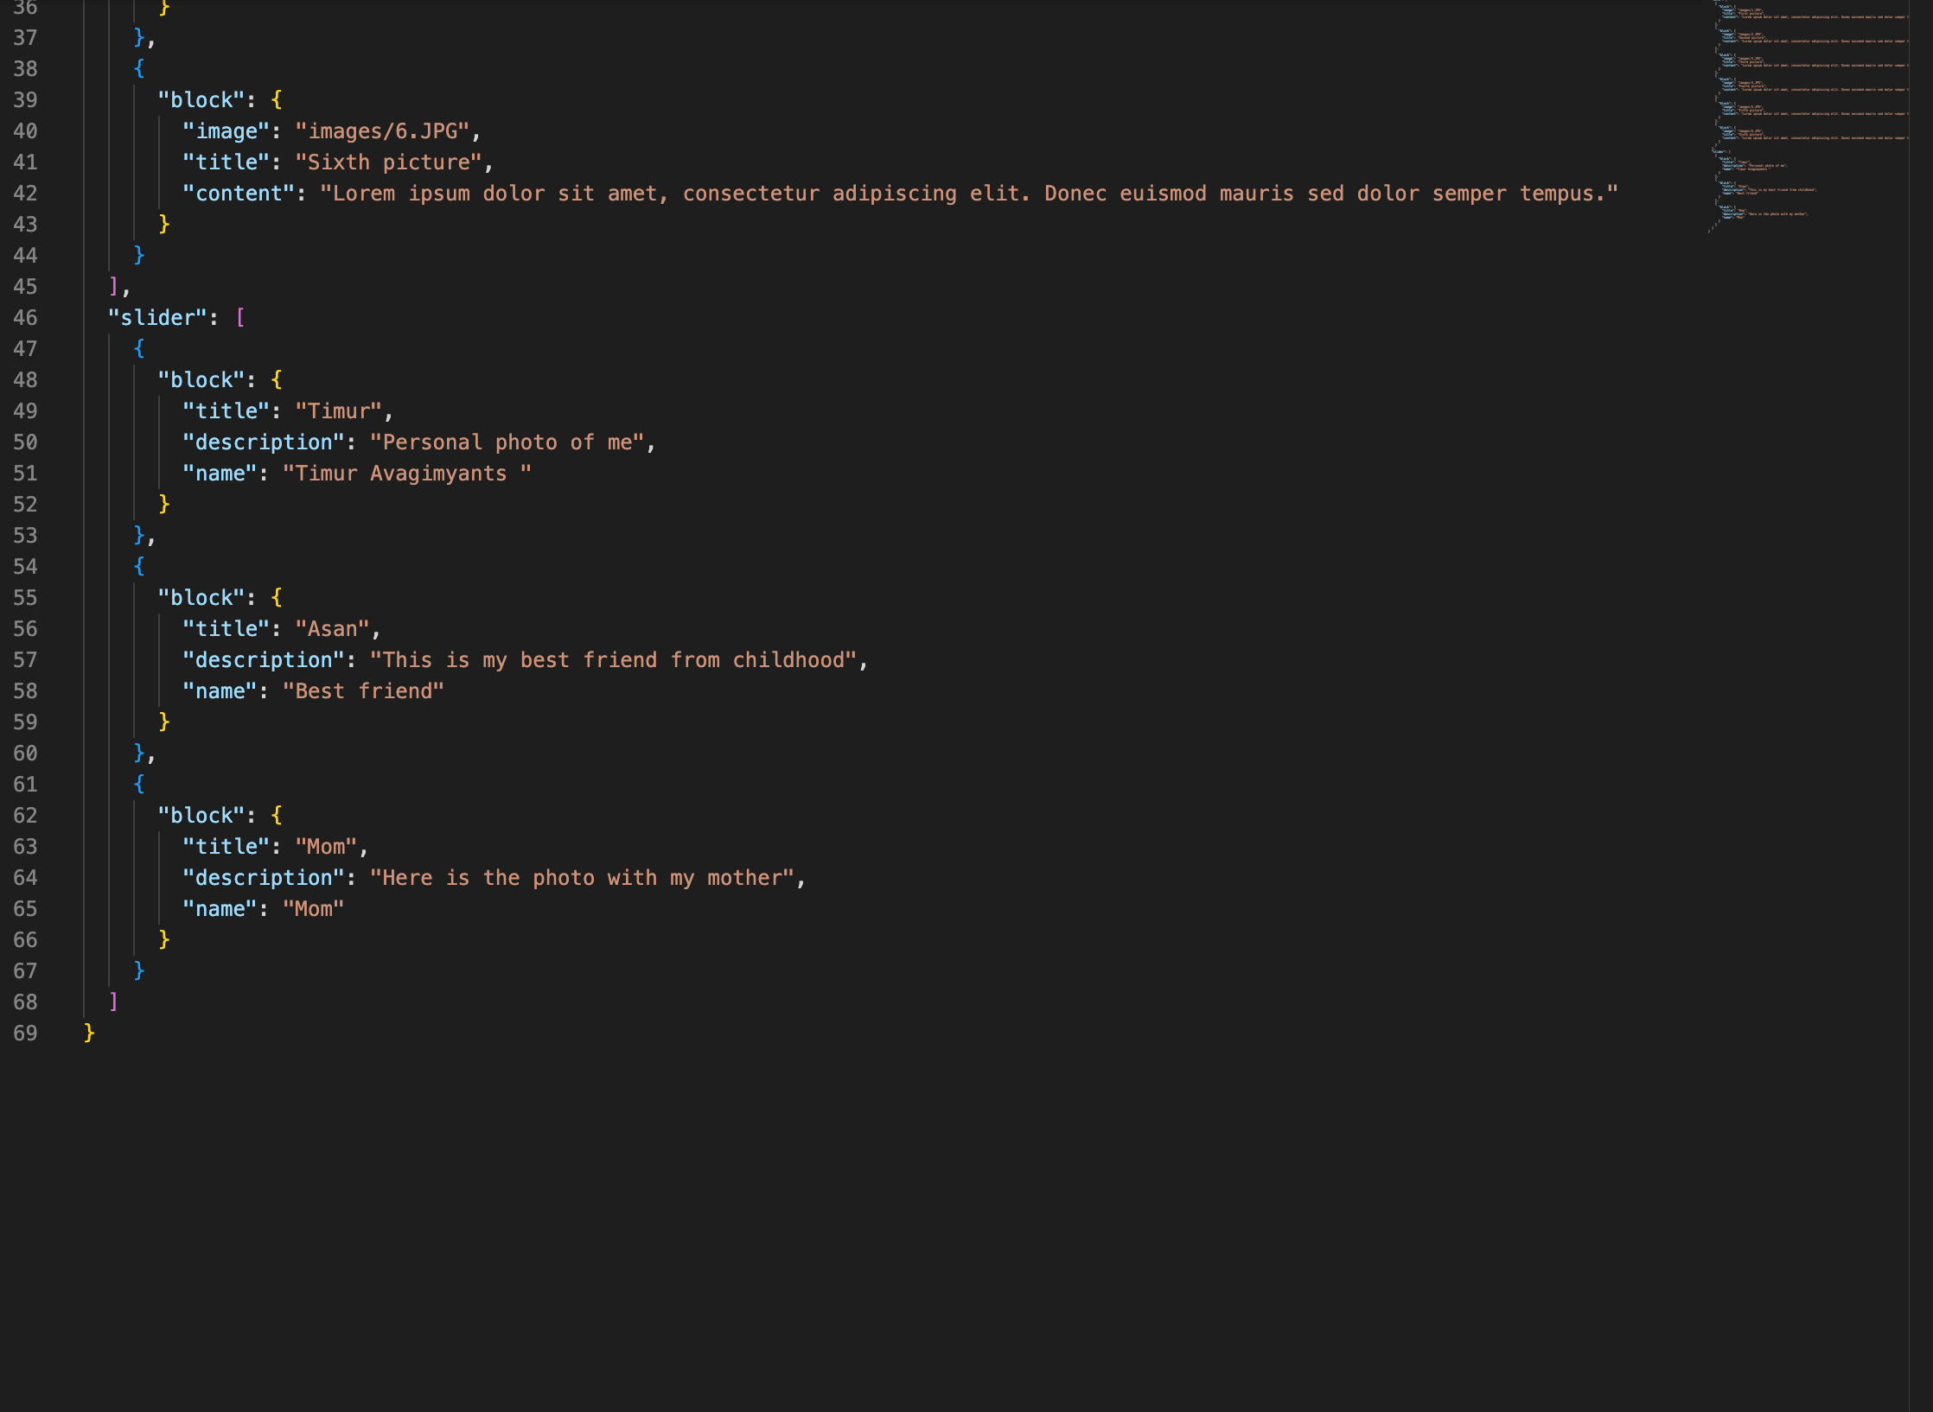

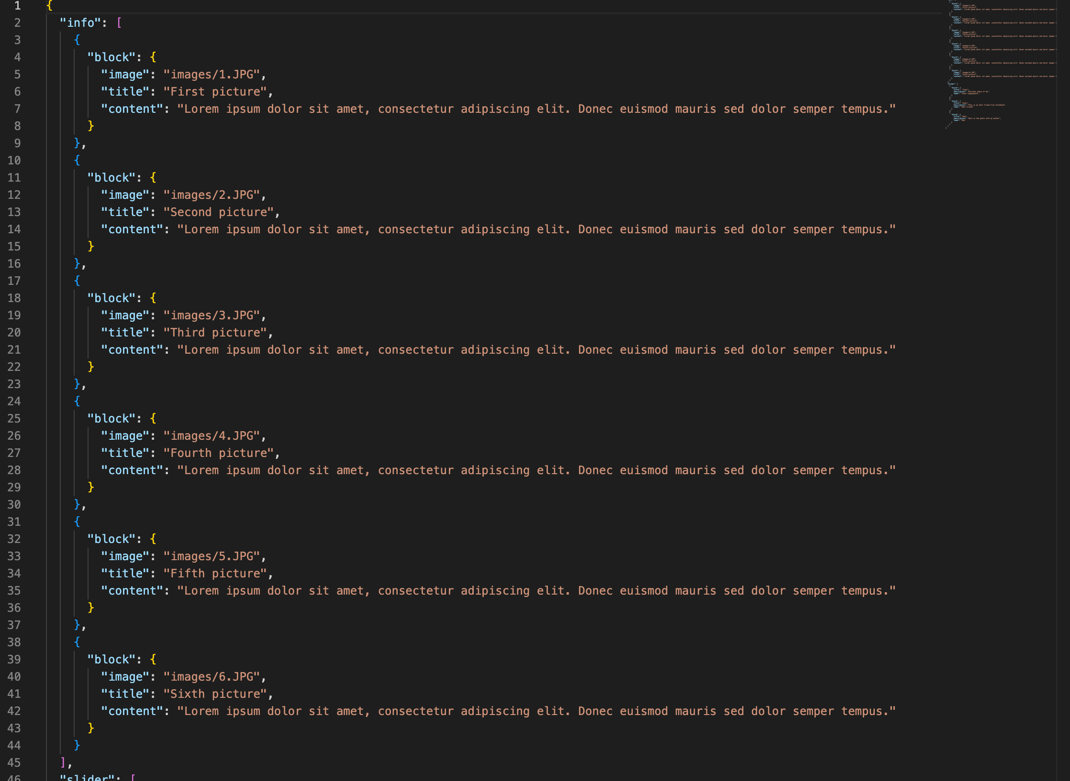

JavaScript Code

Screenshot of the JavaScript code with discussion how it generates the Image Gallery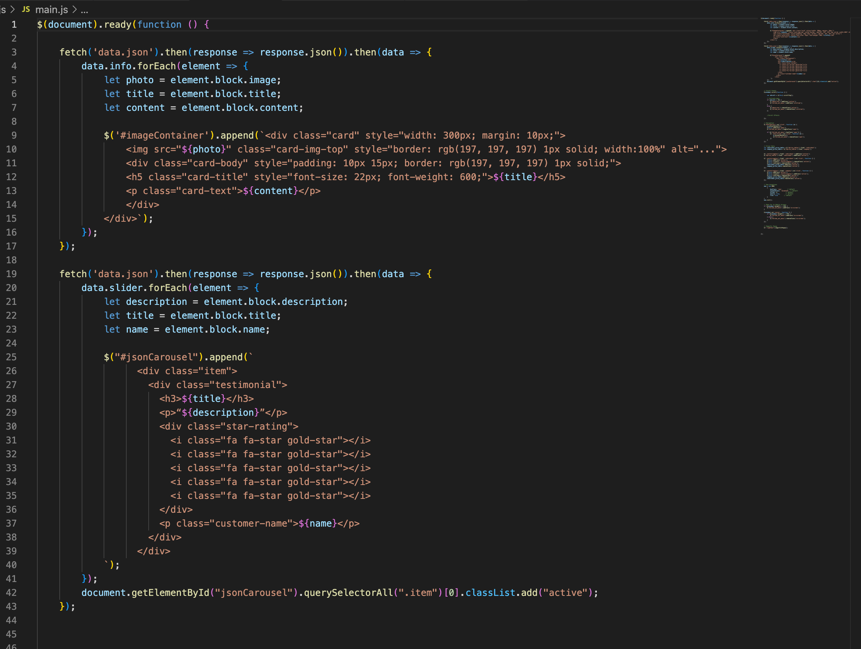

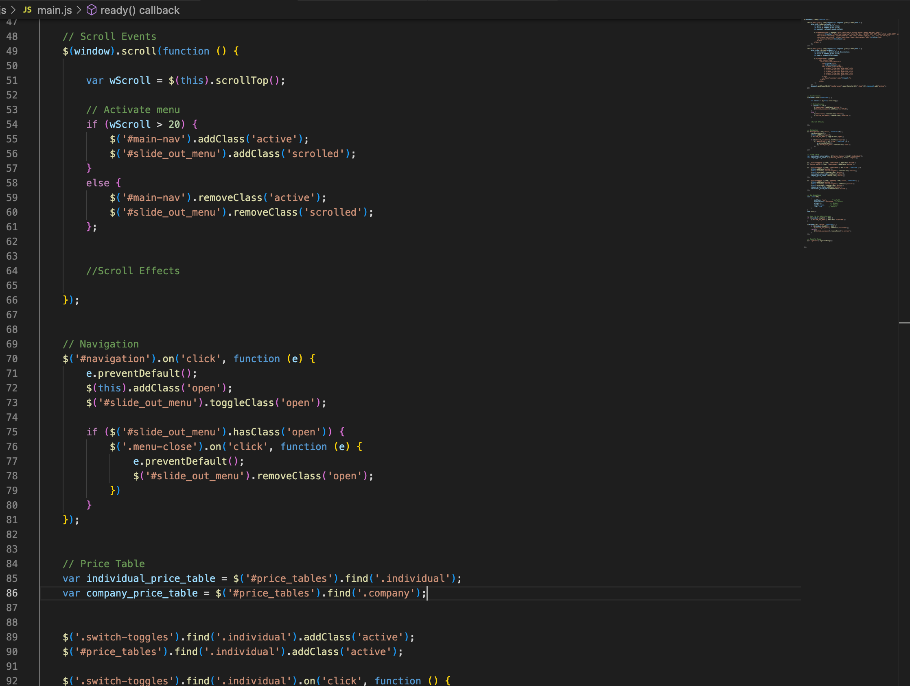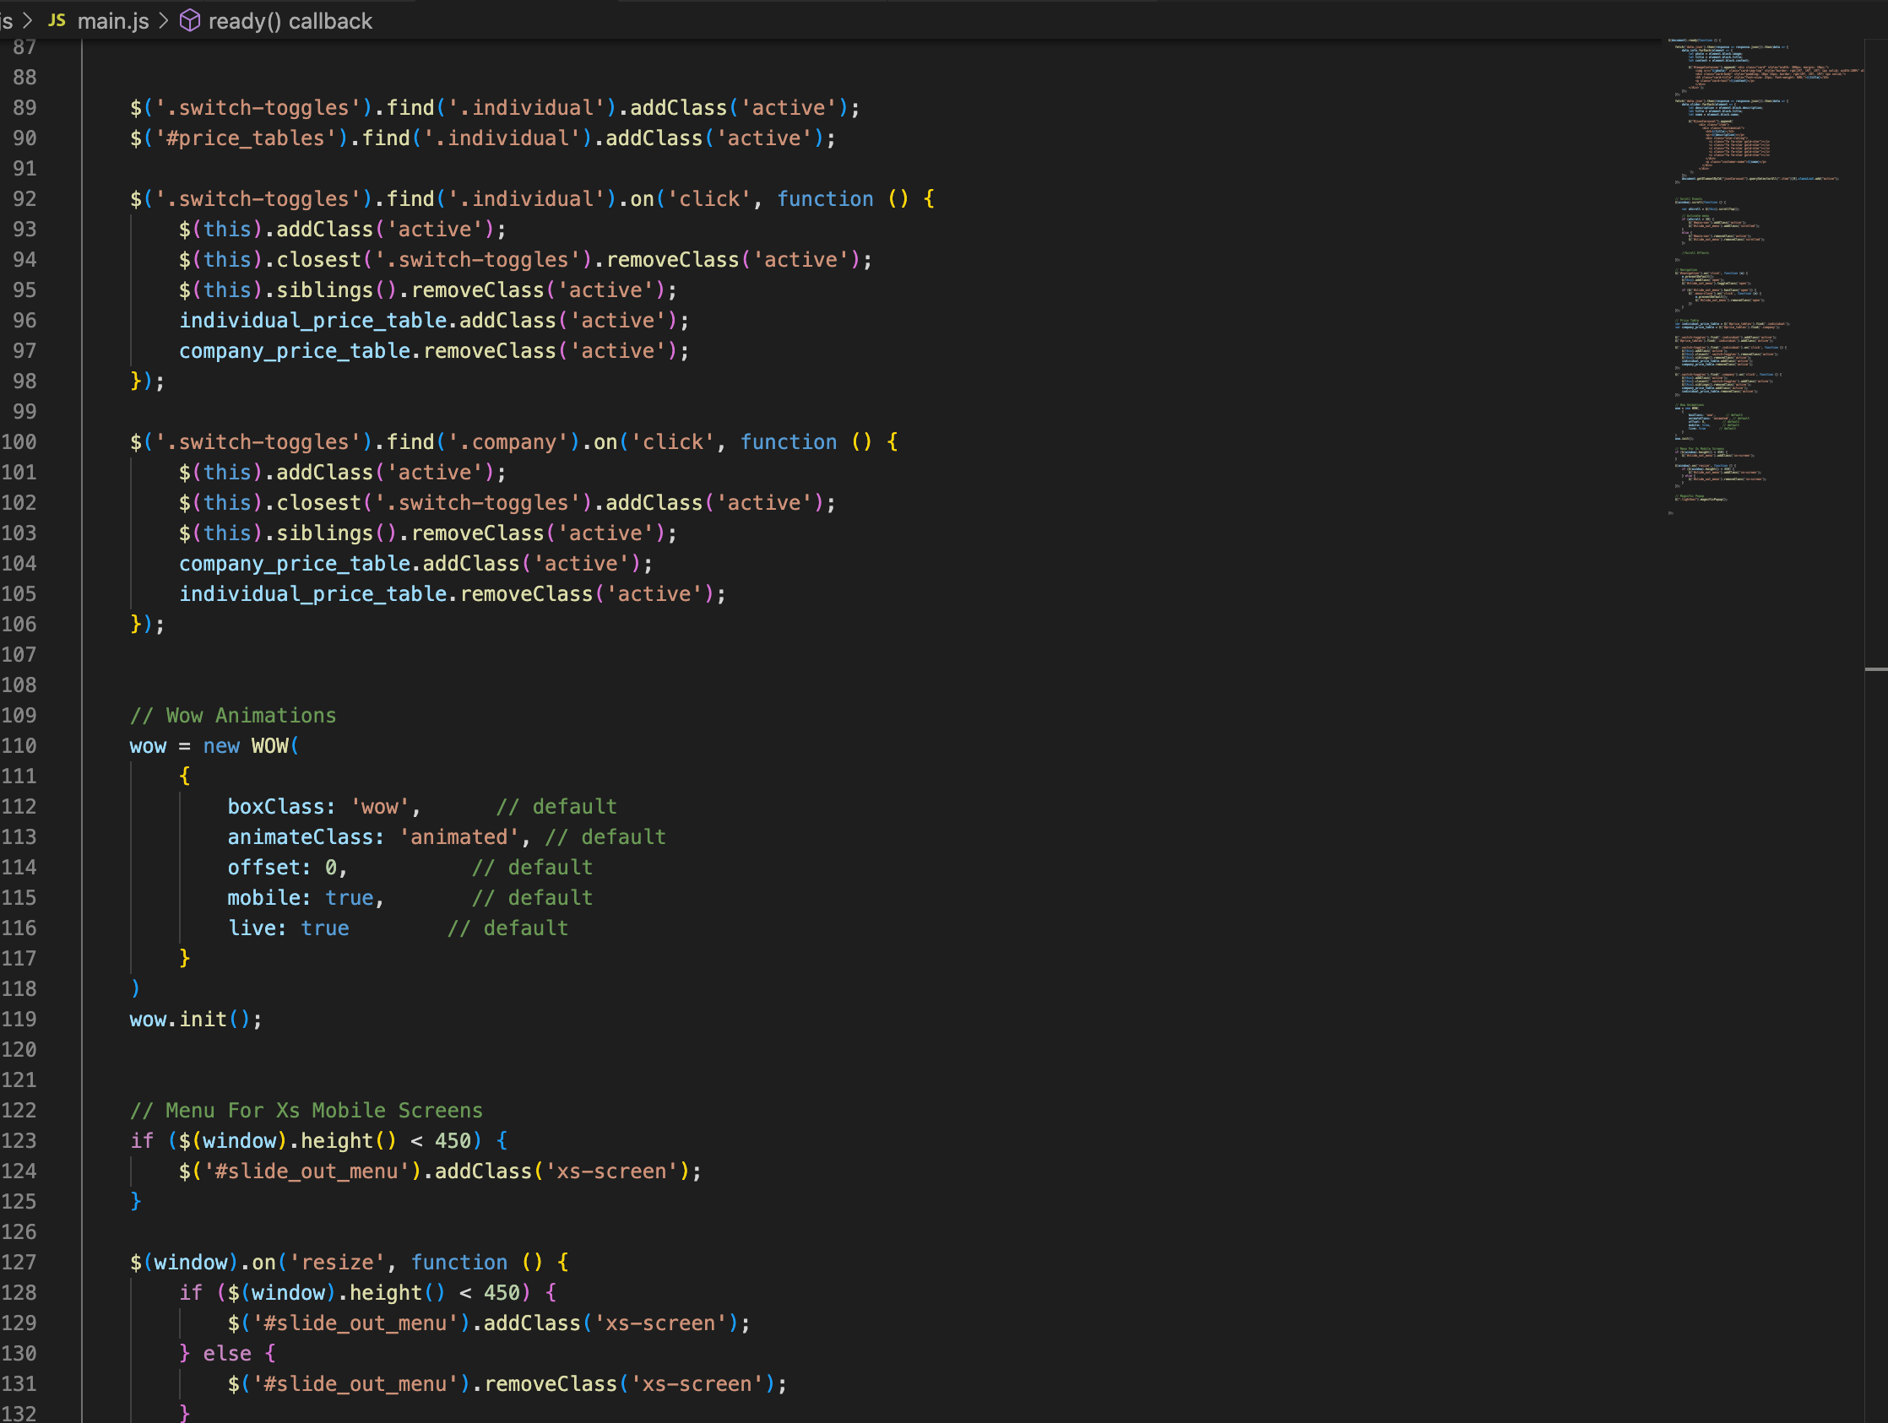

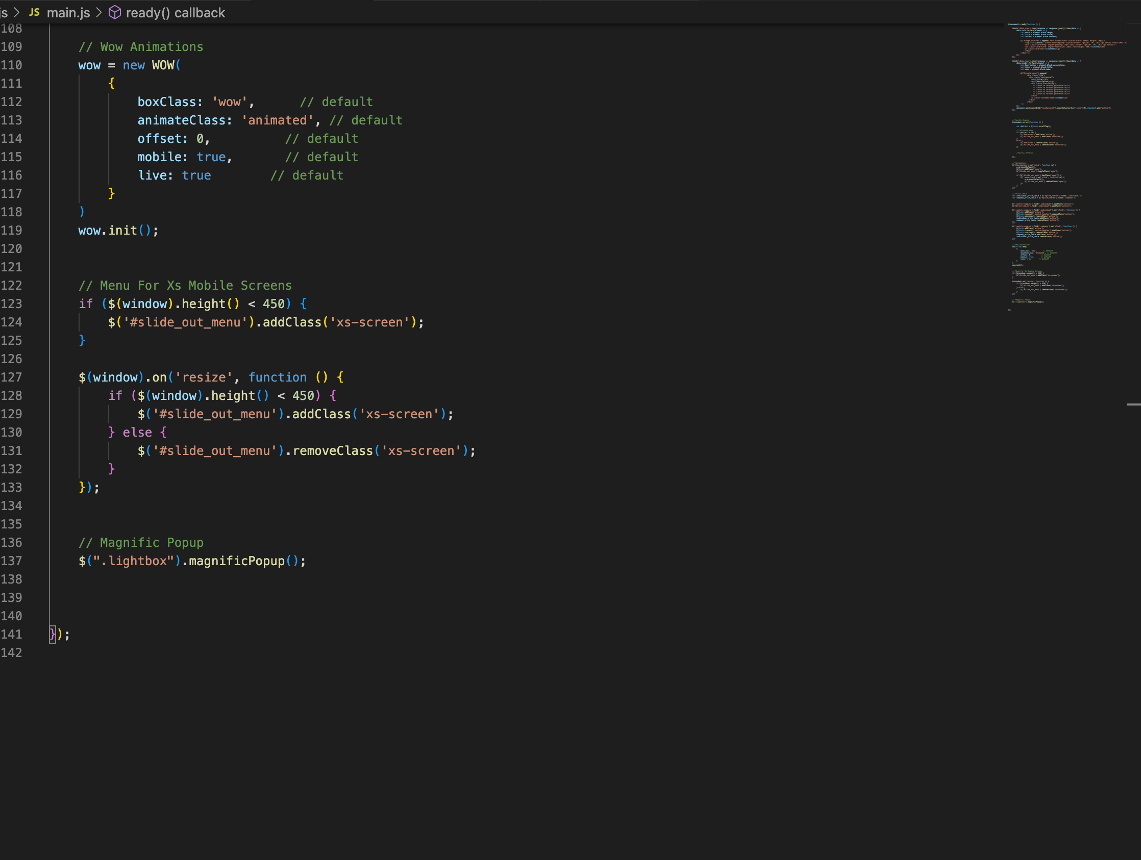

Task 4 - Create an interactive image carousel from a JSON object

Framework Used for Carousel

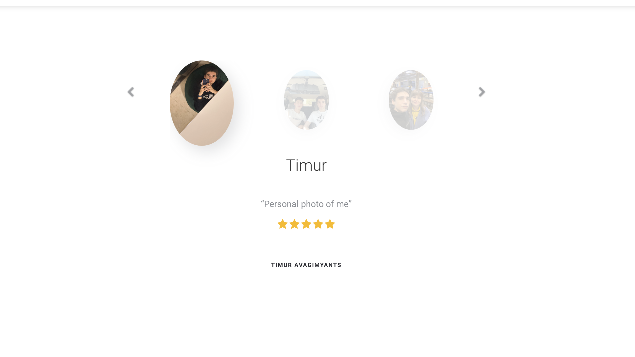

HTML, CSS and JS Code

